Competitor Information

Dear Mini Burn Competitor,

Thank you for entering our Mini Burn event on June 6, 2026 at Penllyn Estate in the Vale of Glamorgan. I hope your preparations are going well.

In this Information pack you will find everything you need to know to help you get to the start line, as well as the finish line.

All start times will be between 10:00 – 13:00. Your start wave will be posted online on 31 May, once the final entries have closed. I will try to accommodate for all individual requests as much as possible.

If you have any further questions after reading this, then please don’t hesitate to contact me.

I look forward to seeing you on the day.

Maria Leijerstam
Mini Burn Race Director
m: 07862 227187
maria@burnseries.co.uk

Contents

- Venue & Timings

- Registration

- Route

- Checkpoints

- Rules

- Recommended Kit List

- Catering, T-shirts, facilities & camping

- Photography

- Medic & Emergency Contacts

- Insurance

1. Venue & Timings

Mini Burn will take place at Penllyn Estate, Cowbridge, Vale of Glamorgan, CF71 7FF

The nearest exit on the M4 is Junction 35 and you will find the entrance to the estate directly off the A48. Once you arrive at Penllyn Estate please follow signs for Event Parking. Please do not park in the Car Park to Forage Farm Shop as you will be asked to move your car. Parking is free alongside the entrance road as you enter the Estate. The event centre is less than 100 metres from the parking.

The registration marquee will be open from 09:00 until 12:00. You will be allocated a start wave and a briefing time in advance. Please aim to register no more than 30 minutes before your briefing time to avoid queues.

Trophy giving for 1st place in each category (and 2nd & 3rd for the family categories) will take place at approximately 15:00 at the Event Centre.

2. Registration

Registration will take place at the Event Centre. You will be given your race numbers, one which you are to attach to the front of your top and the other to the seat post of your bike, as well as a Sport Ident timing chip (one per team/pair). We will attach this to your wrist with a non-rip band and demonstrate to you how it works. You will also be shown where to leave your bike in the secured transition area at the Event Centre. Please bring everything you need for the race, to this transition area. In the event of bad weather, there will be a marquee inside the transition area to store items that you can access during the race.
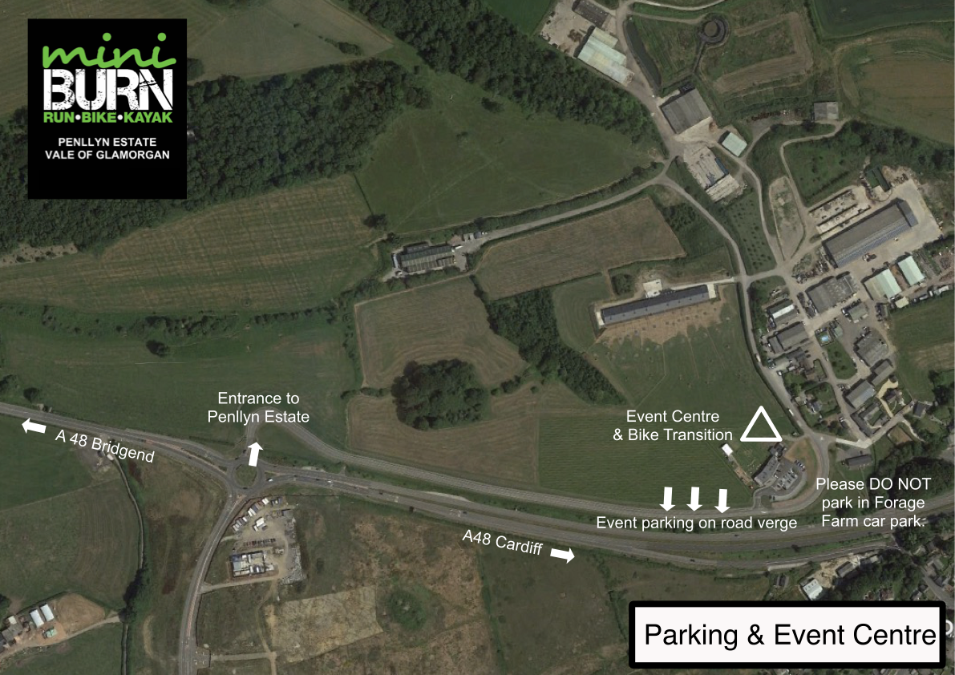
3. Route

The course is fully sign posted, however from time-to-time signs are moved by the public hence it is important that you study the maps below. It will be a punch start, meaning you will place your timing chip into a control under the start arch to start your race time.

Phase One: Run with Adventure Challenges

The run is 2.8km on undulating terrain, starting and finishing at the Event Centre. It is on a combination of surfaces, so trail shoes are recommended. It will be fully sign posted with ORANGE MARKERS.

There will be two adventure challenges during the run phase which will be disclosed on the day.
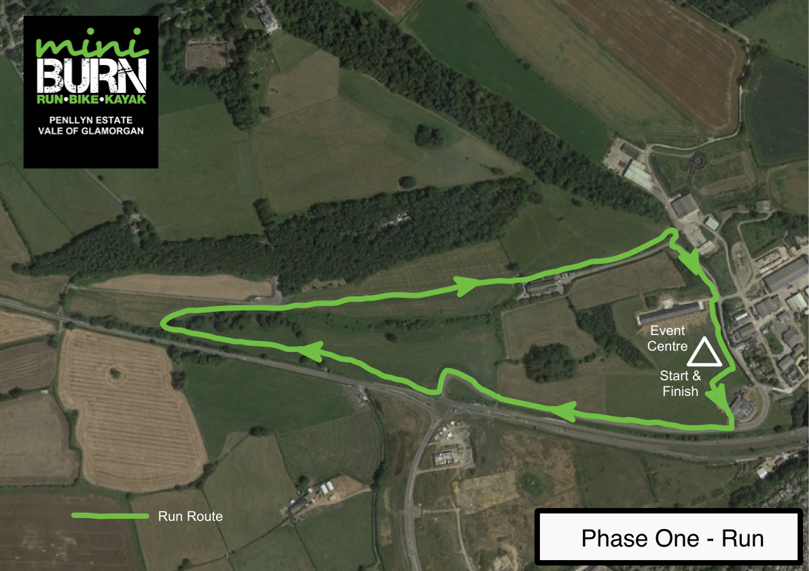

Phase Two: Bike 1

Following the run phase, you will set off on the first bike phase which is 2.6km. You will need to take with you anything you want for the rest of the event on this phase. (Please see * in recommended clothing and equipment list in section 6) This bike phase is fully sign posted with YELLOW MARKERS. There is no ascent on this phase however the terrain is varied, beginning with track and road and later turning into grassy tracks which can get very muddy if it has rained in advance. This is an adventure race after all!

There is one short section of public road to cross which will be marked clearly for both racers and motorists. Please be very careful here. It is a quiet back road, but please remain vigilant.

At the end of this phase, you will leave your bike at the Kayak Transition area.

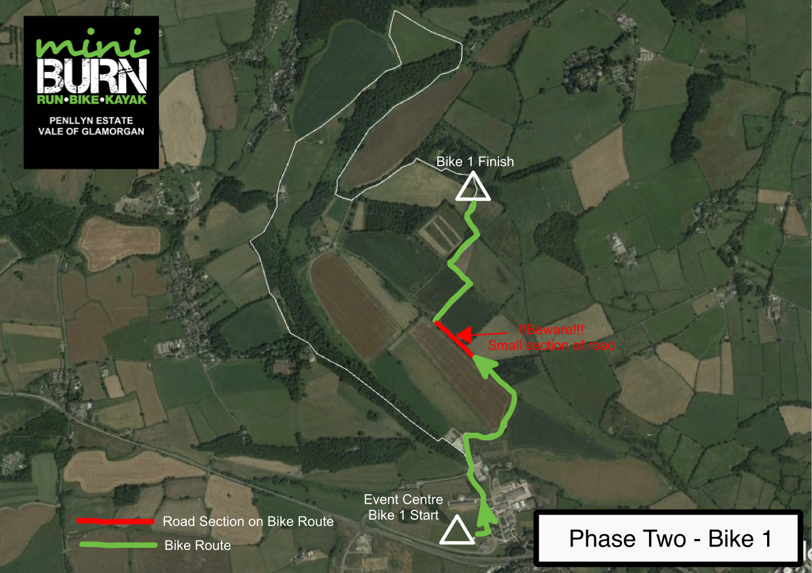
Phase Three: Kayak

Once you have left your bike at the kayak transition area you will be directed to the start of the kayak by a marshal.

When you get to the lake, please follow the instructions of the marshals. You will be given a buoyancy aid and a paddle each and allocated a kayak. Once your buoyancy aid is on, you will be assisted to get into the kayaks if required and safely launched.

The lake at Penllyn Estate is small but adventurous!

Once you have completed your two loops you will be directed where to come ashore and helped to get out of the kayak if required. Please return your buoyancy aids and paddles to the marshal.

You are very likely to get a wet bottom and splash from the paddle. (Please see * in recommended clothing and equipment list in section 6)

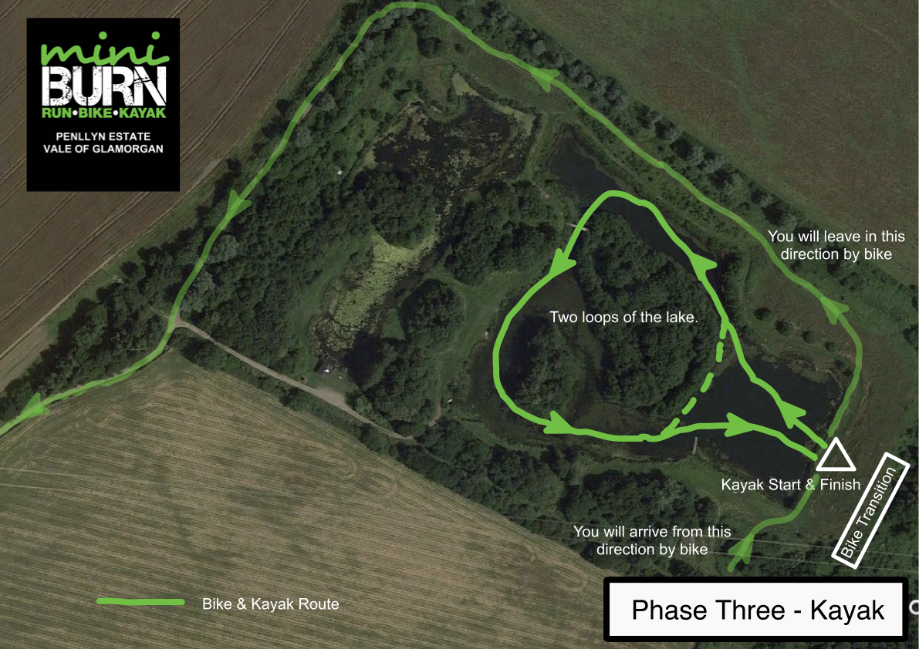

Phase Four: Foot Navigation

After the kayak you will be given a map. There will be five check points for you to find in and around the lake. The navigation will be very simple and there will be a clear description of each check point location.

You can visit the check points in ANY ORDER and ONLY ONE IS COMPULSORY. Time penalties will be given for those check points you don’t visit.

Phase Five: Bike 2

After the foot navigation you will return to the bike transition area to collect your bike.

Once out on the track you will begin a small climb immediately and later a more challenging climb to get you right to the top of Penllyn Estate. It will be hard but stick with it! It’s well worth it for the view and remember there is no need to rush, just take your time. Once you have completed the climb, you will see a check point as you go through a gate. Make sure you punch this check point as it tells us you have done the whole course. It will be well signed.

After rounding the crop field, there will be an 800m section of public road which will be marked clearly for both racers and motorists. Please be very careful here as the road has not been closed off. It is a quiet back road, but please remain vigilant.

The end of the course is a gentle decent on a single track with some loose stone that takes you past the spectacular Penllyn Castle. The course is just over 6km.

If you prefer to do a short course bike, approx. 3km then please speak to us at registration and we will advise you on this.

Throughout the course you will be riding on hard pack trails, a little tarmac, some grass and some rocky terrain. Please take your time and always ride within your ability. There is nothing wrong with dismounting and pushing your bike occasionally. The route will be clearly marked with YELLOW MARKERS.. Everyone is to punch their timing chip, on completion of this bike phase, in the Finish Control which you will find under the Finish Arch.

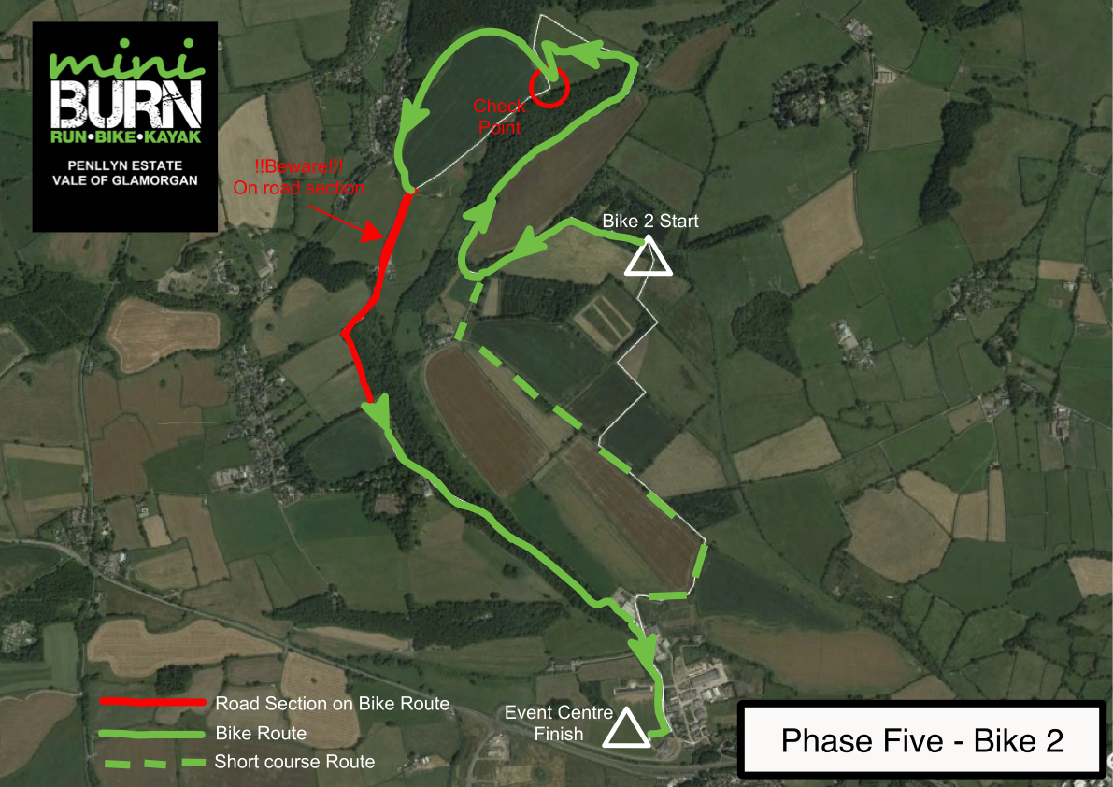

4. Check Points & Timing Chip

It is vitally important that you look after the timing chip that is issued to you at registration because if it is lost or damaged not only will you not receive a race time, you will also be charged for it, which we really don’t want to have to do. They are expensive!

When you have completed the race, please come straight to the download marquee where we will download your results from your timing chip as well as cut the non-rip band off. Please do not do this yourself.

Once you have returned your timing chip you will be given your Mini Burn medal.

You will receive an overall race time. Race positions will be based on Points first followed by time.

Below are all the check points that you will find around the course and the associated points.

Phase One (Run) : Start Control - Compulsory
Phase Four (Orienteering) : Five check points - Minimum of one compulsory (10 points per check point)
Phase Five (Bike) : Middle of the Phase top of the hill – (Optional 30 points)
: End of the phase in the Finish Control - Compulsory

5. Rules

Pairs and teams MUST STAY TOGETHER at all times and FOLLOW THE PRESCRIBED ROUTE. The route has not been closed off to the public so please always give way and ensure you pass, leaving them with plenty of room. The road sections have not been closed off for the event either so please cycle very carefully along them. HELMETS MUST BE WORN ON THE BIKE PHASE and finally make sure you have LOTS OF FUN!

6. Recommended Kit List

Per Person | Per Pair/Team
A well-maintained mountain bike with a good treaded tyre for off road | Fully charged mobile phone
Cycle helmet - COMPULSORY | Basic first aid supplies (plasters, wound dressing)
Waterproof jacket * if rain is likely | Bike pump, spare tube & tyre levers
Trainers and/or Cycling Shoes | Chain tool
T-shirt or long sleeved sports top
Running shorts/leggings and/or cycling shorts
Water-bottle or hydration system
Energy bars/gels or similar food to eat en route
Cycling gloves
*If you are wearing cycling shoes for the bike phases, you may want to carry your trainers in your bag if you are not comfortable doing the foot orienteering phase in your bike shoes.
*If you want to try and stay dry during the kayaking phase, you may also want to take a waterproof top and bottoms for the kayaking section. Most people however, just kayak in their cycling gear.

7. Catering, facilities & accommodation

The event centre is located directly in front Forage Farm Shop and Kitchen. There is also Forage Away take away selling delicious hot and cold snacks and drinks and a hog roast will be available on the day. If you are hoping to dine in, then booking in advance is essential as tables are limited and weekends are very busy. You can book your table here. https://foragefarmshop.co.uk/reservations/

Burn Series T-shirts will be for sale for £15 at the event centre. If you included a t-shirt in your entry at the reduced fee, then you can then choose your size and colour of t-shirt at registration.

Limited accommodation is available on Penllyn Estate in the Cowbridge Cabins which are very close to the Event Centre. Book here early to avoid disappointment. http://www.cowbridgecabins.co.uk

8. Photography

There will be a number of photographers present on the day and we will share the images on our facebook page after the event for you to see and purchase.

9. Medic & Emergency contacts

A number of our marshals along with Estate staff are first aid trained. We will also have a dedicated First Responder present on the day. If you need medical assistance then please ask one of the marshals or go directly to the First Responders marquee.

In the event of a SERIOUS or LIFE THREATENING incident, first call 999, then call the Race Director on 07862 227 187. Competitors are expected to participate in the spirit of the event and to assist other racers or members of the public in need of medical help.

10. Insurance

Multisport Ltd is covered by all necessary third party insurances. You may like to take out personal injury insurance to take part in the race.

